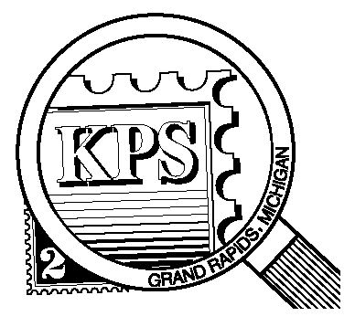

NEWSLETTER OF THE KENT PHILATELIC SOCIETY
P.O. Box 1156, Grand Rapids, Michigan 49501-1156
Louis Morel, President and Editor 269-420-3128
KentPhilatelicSociety.com
kps.stampclub@gmail.com

K.P.S. Philatelist
Volume 70- No. 7 July 2026

KPS Club News
A number of collectors joined our Club this spring. Four joined at the Bourse. Two more signed up at the monthly meeting in May. We welcome Amanda Eding, Jeffrey Gross, Todd Gross, Barbara and Everett Klein, and Steve Smith. We look forward to hearing about their philatelic journeys at an upcoming meeting.  During the June meeting, David Luke shared some of his collection of USA postal items issued to celebrate the country’s bicentennial and this year’s semiquincentennial (a rarely used Scrabble word). David presented commemorative stamps, first day covers, stationery, and a prestige booklet. The USPS has issued a great number of items associated with this country’s independence ranging from politicians, to battlefields, to ordinary citizens who helped shape the country.  The third annual KPS Stamp Social will take place at the Byron Center Baptist Church (address below) on Saturday, July 11 from 10 AM to 3 PM. Have you signed up to attend yet? If not, please call Bill Sobotka (616.531.3295) and let him know that you plan to do so. Food and beverages will be served. We will need some assistance during the lunch period to replenish the food tables. If you would like to help with the restoration of the room on Saturday afternoon, please contact Bill. You will have the opportunity to peruse the inventory of worldwide dealer | Chris Daly and US dealer David Alex. Many additional lots of stamps will be available for collectors to inspect and acquire.  Bill’s “Accumulation Auction” is a plea from Bill to help free space in his house. The lots range from Canada to New Zealand with stops in Greenland and Japan among others. Many early stamps are on the list. Almost all of the stamps are used, yet many have high catalog values. See the accompanying auction list for details.  KPS Archives: The September 1962 issue of The KPS Philatelist reported that Club member Larry Edmunds spoke at the previous meeting “primarily on how to get rid of our collections as we can’t take them with us. And whether our collection is worth only $25 or much more, we should have it organized, and have a written statement as to who should receive it.” He suggested that "We put it in our wills, name some person who knows stamps, and how and where to dispose of them, particularly if the stamps are to be sold.” He added “As we all know, most collections are not sold for as much as are put into them. Choose the right dealer, and expect that he will receive at least 20% from your collection.” That is a crucial component: finding a person who knows stamps. That avoids many disappointments.
The KPS Board will enhance our monthly auctions by holding a drawing for a FREE $10 certificate toward the winning purchases of one lucky member. You need to be present to participate in the drawing.

MONTHLY PROGRAM SCHEDULE
July 28, 2026: KPS CLUB MEETING  5:30 PM Board Meeting  6:30 PM Lot Viewing  7:00 PM Bill’s Accumulation Auction | August 25, 2026: KPS CLUB MEETING  5:30 PM Board Meeting  6:00 PM Lot Viewing  6:45 PM Presentation and Floor Auction
The Kent Philatelic Society meets on the 4th Tuesday of the month at the Byron Center Baptist Church, 7343 Byron Center Ave SW, Byron Center.

Members are invited to share their philatelic experiences in this space. Perhaps you made a special acquisition, or thrive on an uncommon collecting topic, or saw a remarkable exhibit. Share it with your fellow collectors. Contact the Editor with your stories.
Peter Francisco: Contributor to the Cause
This is the fourth and last article on the “Contributors to the Cause” US stamp set – Scott #1559-1562 issued for the United States Bicentennial. The previous articles appeared in the KPS Philatelist in the April 2022 (volume 66, no. 4), May 2026 (volume 70, no. 5), and June 2026 (volume 70, no. 6) issues.

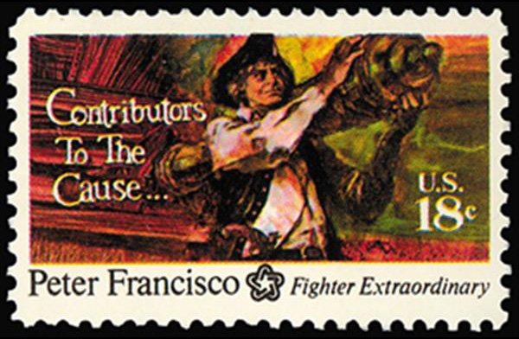
Peter Francisco, often celebrated as the “Virginia Giant” or the “American Hercules”, stands as one of the most physically imposing and legendary soldiers of the American Revolutionary War. His story blends documented heroism with the kind of larger-than-life folklore usually reserved for mythic warriors. Born in 1760 on the Portuguese island of Faial in the Azores, Francisco’s early life took a dramatic turn when he was mysteriously abandoned on a Virginia wharf at the age of five. Raised as an indentured servant on a plantation, he grew into a man of extraordinary size and strength—reportedly around six feet six inches tall and over 250 pounds, towering over most men of his era. The stamp above, Scott #1562 issued in 1975, shows Francisco carrying a cannon.

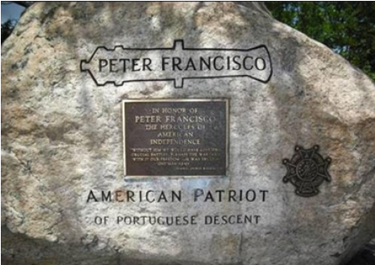
Francisco’s reputation was forged on the battlefield. He joined the Continental Army in 1776 and quickly became known for feats that seemed almost superhuman. At the Battle of Brandywine, he fought fiercely despite being wounded. At Germantown, he pressed forward through smoke and confusion. But it was at the Battle of Stony Point in 1779 that Francisco’s legend truly took shape. During the nighttime assault led by General “Mad Anthony” Wayne, Francisco is said to have killed multiple British soldiers, scaled the fort’s walls under heavy fire, and helped capture the enemy flag. His bravery earned him commendation and a reputation as one of the most formidable fighters in the Continental ranks.

Another famous episode occurred at Guilford Courthouse in 1781. When American forces began to retreat, Francisco reportedly refused to abandon a cannon. Instead, he lifted the 1,100-pound piece—an act historians debate but which remains central to his legend—and carried it away from the British. In the same battle, he is credited with cutting down eleven enemy soldiers in close combat. These stories, whether embellished or not, reflect the awe he inspired among both comrades and opponents.

Francisco’s service did not end with the war. After independence, Francisco became a popular raconteur retelling the dramatic tales of heroic feats he performed. He became a respected public figure in Virginia, serving as Sergeant-at-Arms for the State Senate and working as a blacksmith and landowner. Americans have always loved a good hero and a good story, and in the years after the American Revolution, the legend of Peter Francisco continued to evolve in American memory.

Though he never achieved wealth or high political office, he remained a symbol of patriotic strength and perseverance. His death in 1831 from appendicitis marked the end of a life that bridged fact and folklore, but his legacy endures in monuments, historical societies, and the continuing fascination with his extraordinary exploits.

Peter Francisco’s story resonates because it embodies the spirit of the Revolution: ordinary individuals rising to extraordinary challenges. His blend of mystery, physical power, and battlefield heroism ensures that he remains one of the most unforgettable figures of America’s fight for independence.

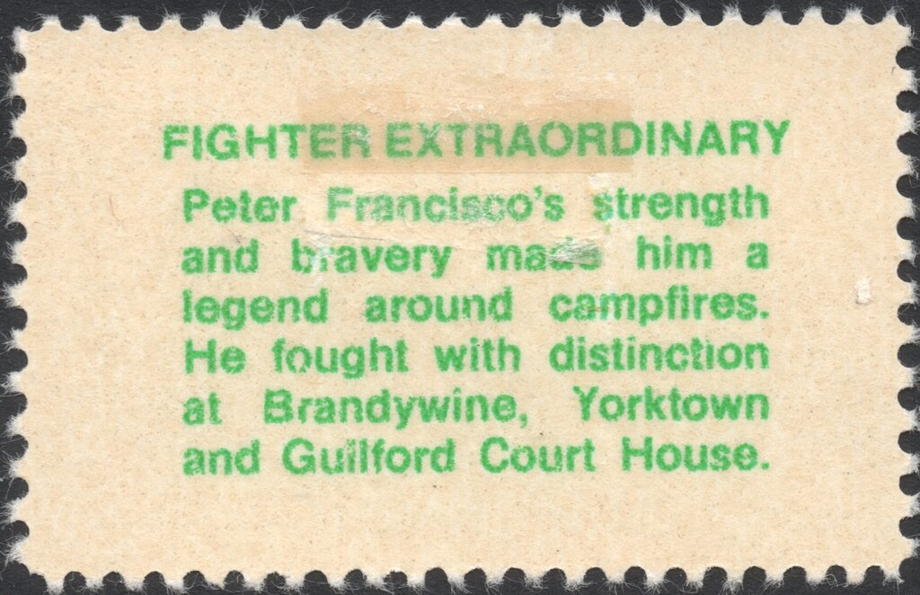
A description of the stamp’s design is printed in green on the reverse of each stamp in this set, beneath the gum. On the reverse of the Peter Francisco stamp is written "Fighter Extraordinary: Peter Francisco's strength and bravery made him a legend around campfires. He fought with distinction at Brandywine, Yorktown and Guilford Court House."

The City of New Bedford, home to a large community of Portuguese-Americans, and the Massachusetts Society of the Sons of the American Revolution dedicated a square to Peter Francisco’s memory. The Peter Francisco Society joined in to dedicate a monument in his honor in 2007.

Dan Ondersma

